**INNOVATIVES IN SMART WATER MANAGEMENT**

**PROJECT_TITLE:SMART WATER MANAGEMENT SYSTEM**

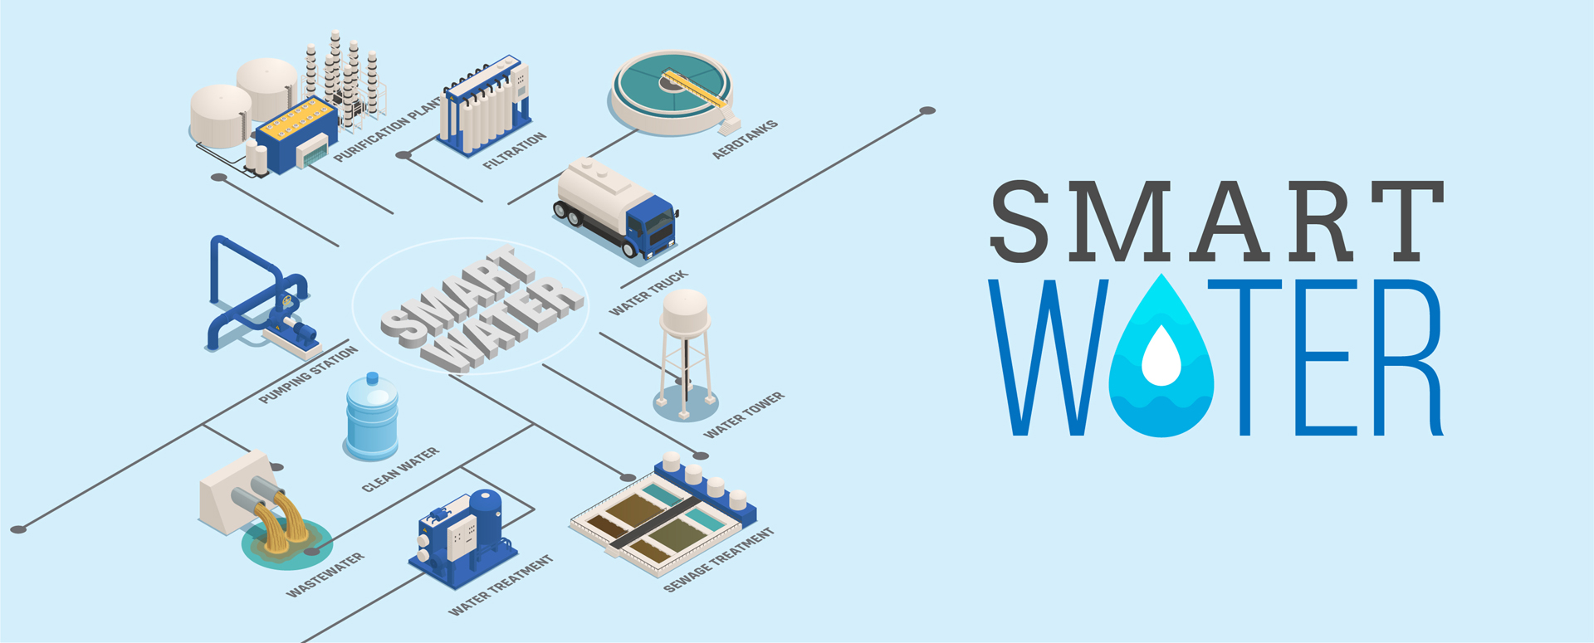

Innovations in smart water management are used to improve the efficiency, effectiveness, and sustainability of water management systems. These innovations include a wide range of technologies, such as:

* Sensors: Sensors can be used to monitor water quality, quantity, and flow in real time. This data can be used to identify leaks, detect contamination, and optimize water distribution.
* Internet of Things (IoT): IoT devices can collect and transmit data from sensors to a central system for analysis and control. This allows for real-time monitoring and management of water systems.
* Artificial intelligence (AI): AI can be used to analyze water data and identify patterns and trends. This information can be used to make predictions and recommendations for improved water management.

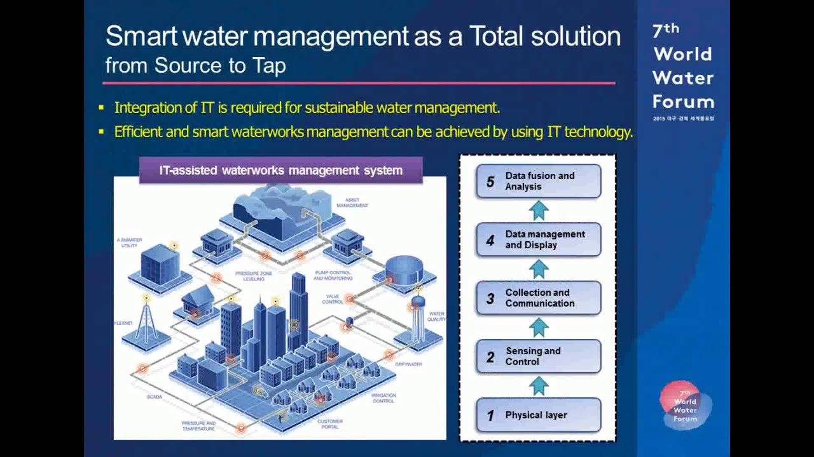

Some specific examples of innovations in smart water management include:

* Smart water meters: Smart water meters can track water usage in real time and provide customers with detailed information about their water consumption. This information can help customers identify areas where they can conserve water.
* Leak detection systems: Leak detection systems can identify and locate leaks in water pipes and other infrastructure. This helps to reduce water loss and prevent damage.
* Water pressure management systems: Water pressure management systems can help to ensure that water pressure is maintained at optimal levels throughout a water distribution system. This helps to reduce leaks and improve water efficiency.
* Demand-response systems: Demand-response systems can encourage customers to reduce their water consumption during peak periods. This can help to manage water resources more effectively and reduce costs.

Innovations in smart water management are still in their early stages of development, but they have the potential to revolutionize the way we manage water resources. By using these technologies, we can improve water efficiency, reduce water waste, and protect water quality.

Here are some specific examples of how smart water management innovations are being used around the world:

* In Singapore, the government is using smart water meters and leak detection systems to reduce water losses by 50%.
* In Barcelona, Spain, the city is using smart water management technologies to reduce water consumption by 20%.
* In California, USA, the Metropolitan Water District is using smart water management technologies to manage water resources more effectively during droughts.

These are just a few examples of how smart water management innovations are being used to improve water management around the world. As these technologies continue to develop, we can expect to see even more innovative ways to use water more efficiently and sustainably.